Earthquake detector using Arduino

1—comopnents along with the price
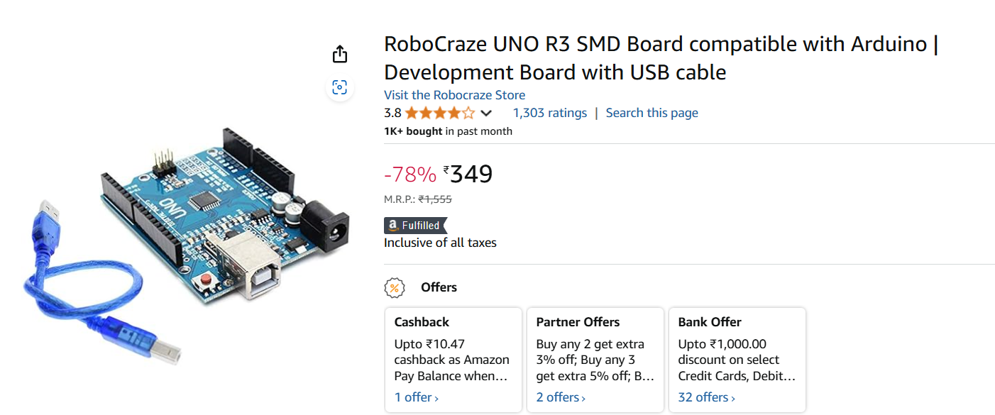

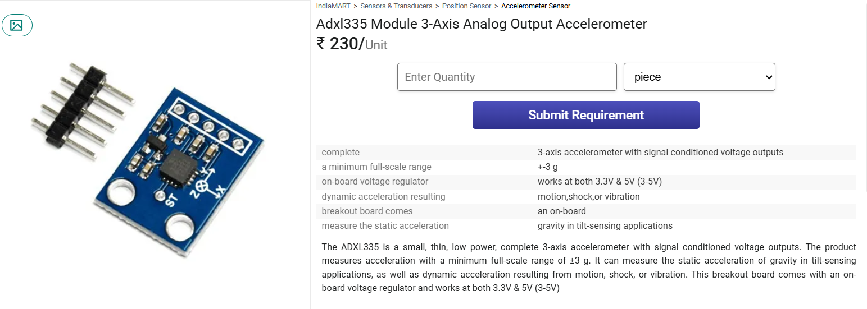

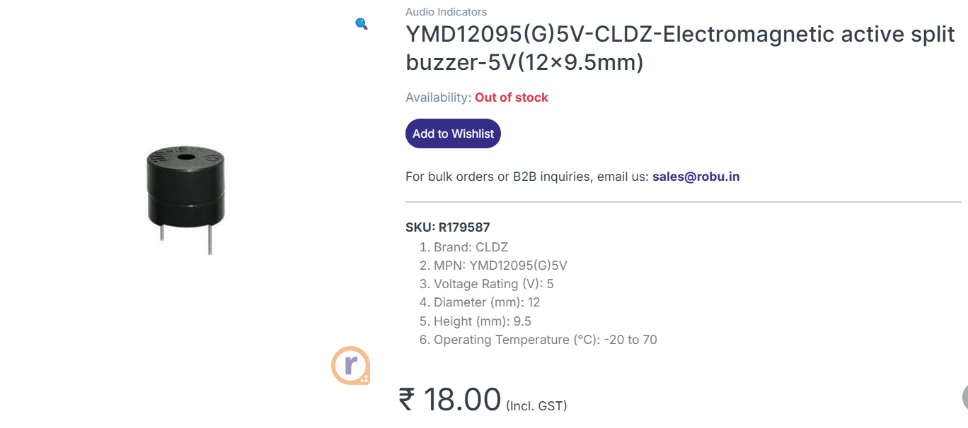

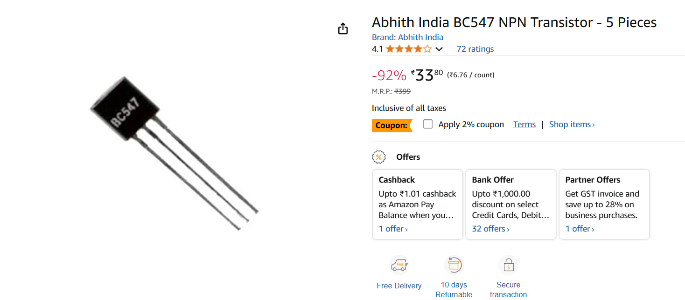



2---- different models for the same project

a>> earthquake detector using Arduino and mp 6050

b>> earthquake detector using Arduino and adxl335 acceleometer

